(Approx. 1,919 words)

Painter X Product Review
by Tom Ekvall, newsletter editor and “Creative Imaging” Columnist, Northeast Wisconsin PCUG
http://webpages.charter.net/newpcug/
tekvall@new.rr.com

Obtained from APCUG with the author's permission for publication by APCUG member groups.

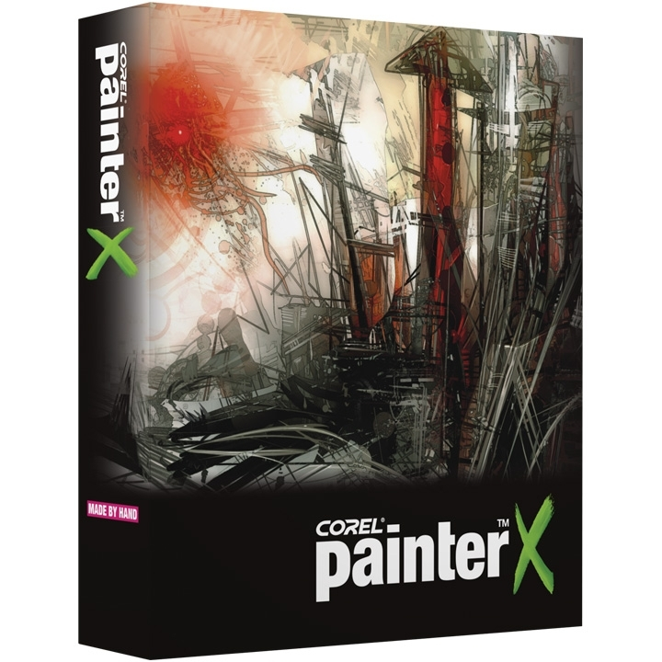
Painter X is everything a photo artist, like myself, could ever want in the way of a digital imaging program—or should I say a digital natural media painting program.

Corel Corporation has done a fantastic job upgrading its marquee program for both traditional painters, who create art from scratch, and those like myself who enjoy creating photo art.

The newest version, released in 2007, is geared towards running on Windows Vista (as well as XP and Macs) and incorporates under the hood performance enhancing improvements designed to make creating photo art a pleasurable experience – without the mess of paints.

I installed Painter X on my laptop, an Acer with Pentium Dual Core processors at 1.60 GHz, and 2 gigabytes of RAM. In the several months I have tried out the product, not once did my computer crash or significantly slow down due to running out of resources.

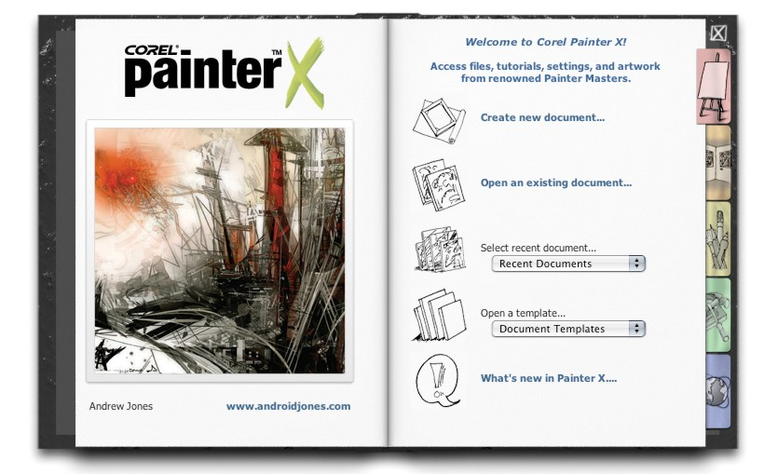
I first became hooked on the full version of Painter after using Painter Essentials 3 (a stripped down version but with plenty of power to create photo art). I got the Painter Essentials 3 free with my Intous3 tablet. A tablet with pen is essential to get the most out of the program, although a mouse will work. However, using a mouse does not give you the pressure controls and other things that a “brush” can do using the pen.

After installing the program, which did not involve any problems, I was greeted with a Welcome Screen in the form of a flipbook. The welcome screen (image on left) gives you tabbed options such as retrieving documents, a gallery of what others have created, extra resources such as tutorials available, setting up Painter, and resources on the web. It can be turned off after you get familiar with the program.

I was pleased with all the tutorials, including video learning, available to help learn the product, which is a complex program but once mastered produces incredible, realistic painted creations that give the feel and texture of a traditionally painted piece of art. Corel goes the extra mile to make sure you have the resources to get the most out of the product and provides links to these resources.

For photographers, a key feature is the Photo Painting System, which includes three modules: Underpainting, Auto-painting and Restoration.

Underpainting
The feature of Painter that I really enjoy is its cloning capability, whereby the colors come from the original source photo (rather than a separate color palette) with the brushes used to transform the image to a desired style. A Quick Clone feature as part of the Underpainting palette creates a copy upon which the photo art will be created. A tracing paper is also created at the time which can be toggled on and off to show the original photo (when on) as a guideline for the applying the brush strokes in the appropriate direction. Turned off, only the painted image is visible on the workspace. This is true whether using the auto-painting feature or applying the brush strokes by hand (pen).

Painter X provides as a new feature a selection of color schemes as part of the Underpainting palette, such as Impressionist, classic, modern, watercolor, sketchbook and chalk. Each style of painting may require changes to the original photo, such as increasing or decreasing saturation, increasing or decreasing contrast or making the colors more or less vivid. Pastels and chalks tend to be softer by nature while oil and acrylics tend to do best with increased saturation. Painter X allows you to use the Photo Enhance sliders as with Painter 9.5 and Painter Essentials 3 to make changes to the color, contrast or saturation; you can even use both to get the desired effect.

Auto-Painting
Despite the numerous brushes, effects, and paper textures that enable you to create every possible style of painting, Painter X also provides an enhanced auto-painting tool for those that may be somewhat artistically challenged as to painting, but want to create watercolor, oil, pastel, acrylic, chalk, charcoal or impressionist-style artwork.

After making selections of bush stroke, opacity, brush size and other variables, you then rely on the program to automate the process of creating the art work with the touch of the “Play” button on the palette. No continuous drawing of brush strokes is required.

The auto-painting feature does a very good job of creating a realistic “painted” photo from my experience using this tool. Some may wonder why a high-end program would even offer an auto-paint palette. I find it desirable, as it gives me a chance to experiment with different strokes, brush sizes, paint brush styles, and other factors and produce a final product within a relatively short period of time. If I apply by hand (not using auto-paint), I use a low level of opacity to gradually build up the color values and style, and this takes time.

What is new, and which I find favor with, is the addition of a speed setting with the auto-paint tool that allows you to slow down the process of creating the picture so that you can stop it, make changes to types of brushes, opacity or size, and continue the process of painting the picture

Another new feature as part of the Auto-painting palette is the addition of Smart Stroke Painting and Smart Settings, where Painter will vary the stroke width, length, and pressure to follow the forms within the original photo as it randomly applies the brush strokes. There are 16 Smart Stroke Brushes including those for watercolor, chalk, acrylics, sponge, charcoal, colored pencil and more. This is especially helpful to those who may be new to “painting” as they learn and master the types of brushes and effects that can be created.

Restoration
The Restoration feature includes two brushes (a soft edge cloner and a hard edge cloner) that enables you to restore original detail of the photo without a “painted” effect. This is invaluable when working with a portrait and you want to bring out facial features. Also new is the ability to open another photo/image with the desired color scheme and use those colors on the photo being cloned. This is called the Match Palette effect. I have not tried this effect yet.

Below is an image of the Painter workspace with the Photo Painting System and its Underpainting, Auto-painting and Restoration tools on the right hand side.
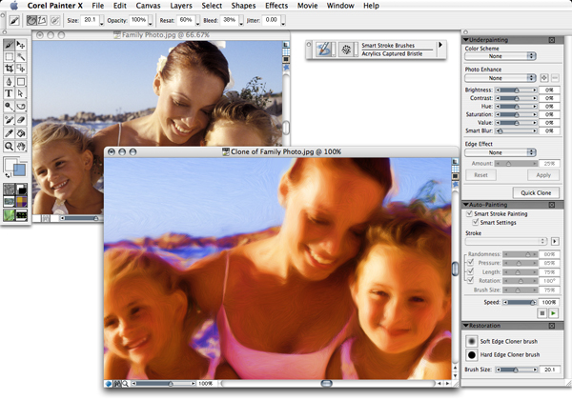
.

Brush selection

There are so many brushes, more than you can imagine. However, some of them soon become favorites as you experiment and see how each performs. I like to use the cloner brushes which are adept at creating photo art from colors in the source photo rather than the Colors palette. Other brush categories can be used to draw color from the source photo by applying the Clone Color option from the Colors palette. It looks like a rubber stamp. If you forget to apply the Clone Color option, the color applied will be from the Colors palette, which I have done on occasion wondering why the color was green (the active color on the palette), rather than the underlying color from the source picture

Brush selection and control can be accessed on a toolbar on top of the workspace, with more than 30 types of brushes and many more variants for each brush style available. The opacity, brush size, and other relevant factors for a brush are also able to be changed on the top toolbar below the menu items.

A major new brush category in Painter X is the RealBristle Painting System, which provides the most realistic rendition of a brush on a canvas, down to individual hairs (bristles) on the brush showing up as if created by a real brush on a real canvas. It seems each new version of Painter comes up with added realism and this one is no different as the RealBristle brushes reproduce the natural movement of the artist’s brush. There are a number of brush variants to choose from such as Real Round Bristle, Real Tapered Wet Flat, and Real Fan Soft. Multiple colors can be achieved with brushes with strokes fading as color is used up in the brush.

The image below depicts RealBristle strokes created by another artist and a dialog box of brush tips.
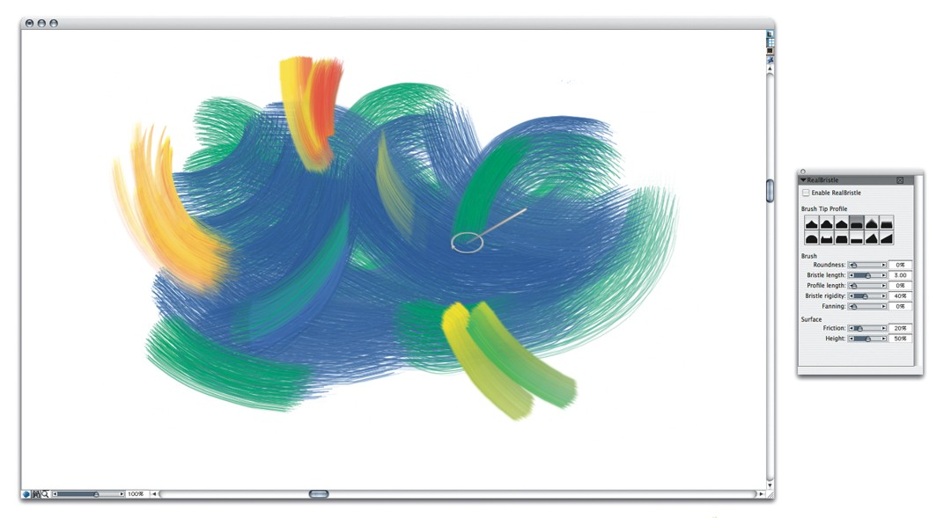
As with prior versions of Painter, you can create your own mix of colors on a palette and blend and apply them to the canvas either to a photo or as a painting from scratch.

What has become an invaluable reference guide for me is Martin Addison’s book, Painter X for Photographers, published by Focal Press. Everything in the book is geared for creating photo art and he goes into detail about each brush and brush variant, applications of the brush where best and pictures of the effect of each brush on the canvas. He also talks about Hand Tinting a photo with Painter X using layers, how to choose brushes, and how to customize brushes. The information is presented in a very understandable format and reduces the learning curve associated with mastering the brushes.

There are a number of other new features of interest to professional designers, photographers, and artists. Suffice to say, this is a great product whether upgrading from a previous version of Painter or Painter Essentials 3, or buying for the first time. I cannot think of any cons about this program. It does what it is supposed to do, providing the ultimate in realism, flexibility and brush control.
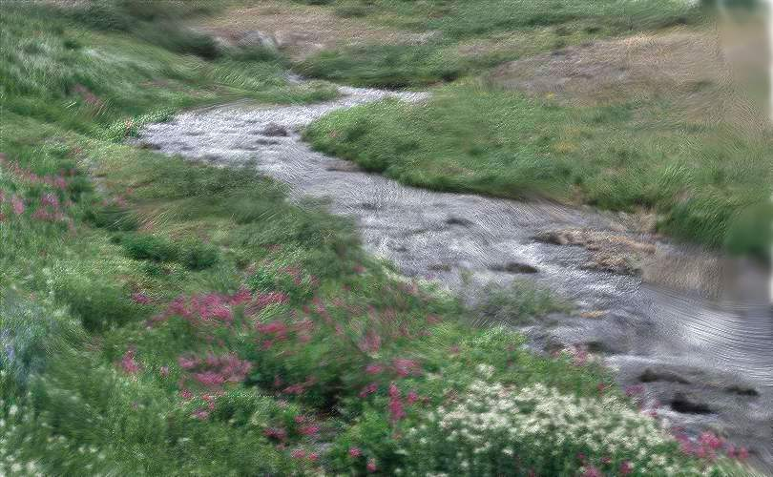

I opened up a photo of a landscape scene and proceeded to paint pictures using a watercolor effect, an oil painted effect, a chalk painting and other styles. See my creation of one of the images painted.

The regular price for upgrading is $219 while purchasing new costs $419. Corel is presently offering discounts through their website (www.corel.com) at $199 for an upgrade and $394 for new users. A 30-day trial version that is fully functional is also available as is Painter Essentials 3 (which runs $99/discounted to $79). The product is worth the upgrade, especially if you are using a computer with Vista installed as the Operating System. Those with Painter 6 or higher qualify for the upgrade price as well as those with Corel’s CorelDraw Graphics Suite X3.

And there are so many goodies provided through Corel and others to make the experience fun, such as brush variations, paper texture effects, new gradients, and more. It is a great creative tool as part of my digital photo art studio, which also includes Photoshop CS3. Note: Corel has continued to make enhancements to Painter to complement Photoshop, preserving layer effects and masks.

System requirements for PCs with Windows include Vista, XP, or Windows 2000 OS; a Pentium III with 700MHz or greater of processing speed, and 256 MB of RAM (512 MB recommended). The more power the better.

My next project is to create “hand tinted” photographs using Painter X. Looking forward to some really cool results.

Artwork in article provided by Corel Corporation featuring paintings and drawings by Andrew Jones (welcome book) and Cher Threinen-Pendarvis (RealBristle strokes) and used with permission.

This article has been provided to APCUG by the author solely for publication by APCUG member groups. All other uses require the permission of the author (see e-mail address above).

